AGT 211: PASTURE AND RANGE MANAGEMENT

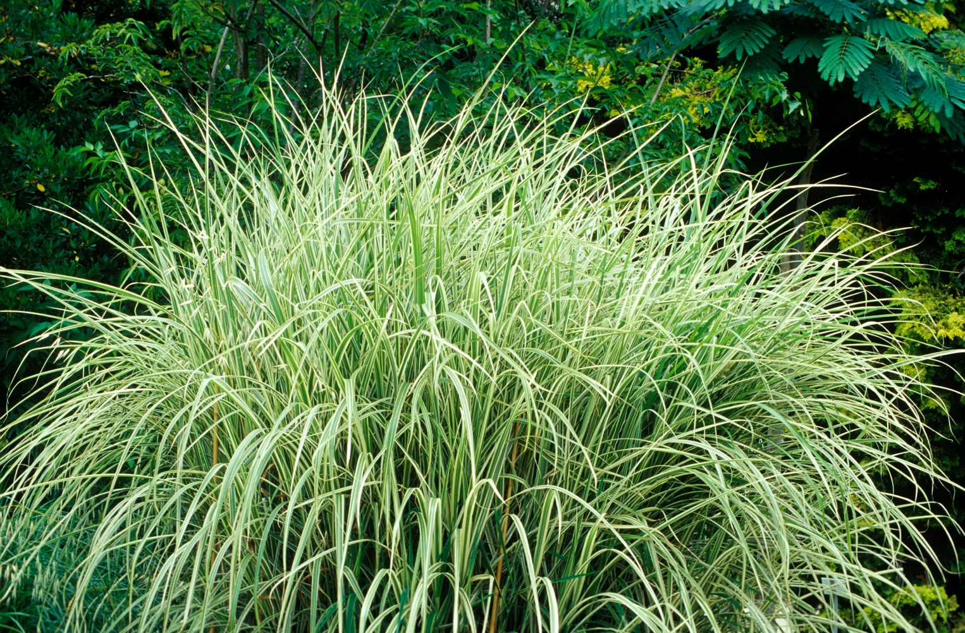

DEPARTMENT OF AGRICULTURAL TECHNOLOGY
EDO STATE COLLEGE OF AGRICULTURE AND NATURAL RESOURCES, IGUORIAKHI CAMPUS

COMPILED BY: MR UD OSAYANDE RAS, MASAN
DEPARTMENT OF AGRICULTURAL TECHNOLOGY
EDO STATE COLLEGE OF AGRICULTURE AND NATURAL RESOURCES
IGUORIAKHI CAMPUS, EDO STATE

Improvement and Management Practices of Pastures and Forage Crops, and Production of Good-Quality Hay and Silage
Improvement and Management Practices of Pastures and Forage Crops
Pastures- These are grazing lands dominated by grasses and legumes.
Forage crops- These are cultivated plants harvested for fresh feeding, hay or silage.
Improved pastures, by contrast, use selected high-yielding varieties. In April 2025, after 48 years, the National Committee on Crop Varieties released eight new varieties through the National Animal Production Research Institute (NAPRI). These include
Grasses
Brachiaria ruziziensis- Bracharia
Chloris gayana- Rhodes grass
Sorghum almum- Sudan grass
Andropogon gayanus- Andropogon
Panicum maximum- Guinea grass
Pennisetum purpureum (Napier grass)
legumes –
Mucuna pruriens- velvet bean
Lablab purpureus- white Lablab/Shika Legume 2
These varieties offer higher biomass (15–30 t/ha/year), better crude protein (8–20 %) and drought tolerance. Grass-legume mixtures are ideal because legumes fix 50–200 kg N/ha/year, improving soil fertility and animal performance.
Establishment follows six clear steps:
- Site selection – The soil should be well-drained, fertileand with ≥700 mm rainfall.
- Land preparation – Bushes should be cleared, plough and harrowed. Soil test (pH and nutrients) should be done.
- Species selection and seed treatment – scarify hard-seeded legumes, inoculate with Rhizobium.
- Planting – broadcast method or drill at recommended rates (5–10 kg/ha for grasses, 2–4 kg/ha for legumes), with vegetative propagation for should be done for Napier.
- Early care – application of basal Phosphorus and potassium should be done. Weed control is done manually or with selective herbicides.
- First defoliation (treaming) – after 8–12 weeks at 10–15 cm height. This is beneficial to the vegetation and helps rapid regrowth and proper spread at maturity
Improvement practices
These include
- over-sowing legumes into native swards
- controlled burning in the early dry season to remove dead material and stimulate regrowth
- fertiliser application (split N for grasses, P for legumes)
Management revolves around;
- Sustainable grazing.
- Continuous grazing is simple but causes overgrazing and soil compaction.
- Rotational (paddock) grazing which is superior and involves dividing land into 4–8 paddocks, with grazing occuring 3–7 days and the land is allowed to rest for 21–42 days. This raises carrying capacity from 1–2 to 4–6 total land unit (TLU/ha) and maintains sward quality. Other systems include zero-grazing (cut-and-carry) for high-value forages and strip grazing.
- Monitor stocking rate (match animals to available forage), sward height and botanical composition.
- Additional practices involves integration with agroforestry (Leucaena, Gliricidia), ley farming (pasture-crop rotation) and fencing.
Major challenges in establishment cost
- Erratic rainfall, seed scarcity (now improving via government programmes)
- Overgrazing
- Bush encroachment and land-tenure insecurity.
- Government initiatives such as the 2025 National Pasture Planting Day and grazing-reserve development aim to address these. When properly managed, improved pastures restore biodiversity, prevent erosion and support year-round feeding.
Making Good-Quality Hay and Silage (approx. 450 words)
Forage conservation bridges the 6–8 month dry-season gap. Hay is dehydrated forage (15–20 % moisture) while silage is preserved by anaerobic lactic-acid fermentation (60–70 % moisture, pH 3.8–4.5).
Hay production (best in short dry spells):
- Select forage – early-bloom stage (Panicum maximum, Rhodes grass or Napier) for maximum nutrients.
- Cut early morning with sickle or mower.
- Field-dry rapidly – spread in thin swaths, ted/turn twice daily; crush stems to equalise drying.
- Test readiness – stems snap, leaves crinkle, no green colour, moisture 15–20 % (grab test).
- Bale or stack under roofed, ventilated barns to prevent mould and termites.
Quality hay indicators
- Green colour
- Leafy
- Pleasant smell
- High palatability.
Challenges
Tropical challenges include sudden rain and high humidity causing mould and nutrient loss (carotene, protein). Artificial drying or rack-drying helps in humid zones.

Key Steps in Silage Making
- Select the Crop and Harvest at the Optimal Stage Choose a high-quality forage crop with sufficient soluble carbohydrates (sugars) for fermentation. Ideal crops: maize/sorghum (at milk to dough stage), tropical grasses (pre-flowering/early heading), or legumes (early podding).
  - Harvest when the plant is young and nutritious — avoid over-mature material (stemmy, low sugar).
  - In tropics, target whole-plant dry matter (DM) of 30–40% (60–70% moisture) for best compaction and fermentation.
  - Cut in the morning on a dry day to minimize field losses.
- Wilt the Forage (If Necessary) If the crop is too wet (>70% moisture, common in fresh tropical grasses), allow partial wilting in the field for 1–2 days (spread in thin swaths and turn occasionally).
  - Goal: Reduce moisture to 60–70% (squeeze test: chopped material forms a ball that holds shape then slowly expands with little/no free juice).
  - Wilting improves packing density and reduces effluent (seepage) losses. Skip for maize/sorghum if already at ideal DM.
- Chop the Forage Chop the material into small pieces (2–5 cm long, ideally 1–2 cm for maize kernels to crack).
  - Use a forage harvester/chopper for uniform size.
  - Small pieces: improve compaction, exclude air better, increase surface area for bacteria, and enhance fermentation speed.
  - In smallholder systems (e.g., manual or tractor-mounted chopper), ensure kernels/stems are broken.
- Add Additives (Optional but Recommended in Tropics) Tropical forages (especially grasses) often have low sugars → add fermentable carbohydrates.
  - Common: Molasses (2–5% by weight), inoculants (lactic acid bacteria), or urea (for nitrogen boost in low-protein forages).
  - Mix evenly during filling to promote desirable (lactic) fermentation and prevent undesirable (butyric/clostridial) spoilage.
- Fill and Compact the Silo Rapidly Transport chopped forage quickly to the silo (bunker, trench, pit, plastic bag, or wrapped bale) to minimize air exposure.
  - Fill in thin layers (15–30 cm) and compact immediately and heavily (tractor wheels, roller, or manual trampling).
  - Aim for high density (>600–700 kg/m³ fresh weight) to exclude oxygen.
  - Fill continuously without long delays to prevent heating.
- Seal the Silo Airtight Cover immediately with plastic sheeting (black/white or oxygen-barrier film), overlap edges, and weigh down with soil, tires, sandbags, or gravel.
  - Seal edges and sides completely to create anaerobic conditions.
  - For bags/bales: Use multiple layers of stretch film.
  - Poor sealing = air entry → mould, heating, and spoilage.
- Allow Fermentation (Storage Phase) Let the silage ferment undisturbed for at least 3–6 weeks (ideally 4–8 weeks for full stabilization).
  - Four main phases occur:
    - Aerobic phase (first 1–2 days): Residual oxygen used up; slight heating.
    - Fermentation phase (days 2–30+): Lactic acid bacteria convert sugars → lactic acid; pH drops rapidly to 3.8–4.5.
    - Stable phase: pH stable; silage preserved if anaerobic.
    - Feedout phase: Open face daily and remove ≥15 cm/day to avoid reheating/spoilage.
- Feed Out Properly When ready, open the silo and feed out from a smooth, vertical face.
  - Remove at least 15–30 cm per day (more in hot weather) to minimize aerobic spoilage.
  - Cover the open face nightly with plastic to reduce air exposure.
  - Discard any mouldy/top-spoiled layer.
Advantages of silage over hay in Nigeria: less weather-dependent, higher nutrient retention, utilises wet-season surplus. Challenges: need for chopping equipment, effluent management and risk of clostridial (butyric) fermentation if poorly packed. Prevention: rapid filling, good compaction and additives.
Conclusion and Summary Sustainable pasture improvement and forage conservation are not optional; they are essential for Nigeria’s livestock roadmap, climate resilience and food security. Adopt mixed pastures with 2025-released varieties, practise rotational grazing and conserve surplus as hay or silage. These practices raise livestock productivity, restore land and reduce conflicts.

Differences between hay and silage
No. | Aspect | Hay | Silage
1 | Moisture Content | Low (15–20% moisture) | High (60–70% moisture / 30–40% dry matter)
2 | Preservation Method | drying | Anaerobic fermentation
3 | Weather Dependence | sunny weather for field drying | can be made during wet/rainy periods
4 | Nutrient Retention | Moderate losses | Generally better retention of nutrients
5 | Suitability | Challenging due to high humidity | More reliable and preferred

Attached Assessment Questions FOR PRACTICE
3 Theory Questions (10 marks each)
- Outline the six steps of improved pasture establishment in Nigeria and explain why grass-legume mixtures are preferred. (10mks)
- List 3 grasses and 3 legumes with their scientific names (10 mks)
- Fill in the missing text in the table below (10mks)
No. | Aspect | Hay | Silage
1 | Moisture Content
2 | Preservation Method
3 | Weather Dependence
4 | Nutrient Retention
5 | Suitability

10 Objective Questions
- Target moisture content for good hay is: a) 60–70 % b) 15–20 % c) 40 %
- Silage is preserved by: a) Complete drying b) Anaerobic lactic-acid fermentation
- Best cutting stage for hay is: a) Mature dry b) Early bloom
- Ideal silage pH is: a) 6.0–7.0 b) 3.8–4.5
- In humid Nigeria, silage is preferred over hay because it is: a) More weather-dependent b) Less affected by rain
- Common additive for tropical grass silage: a) Molasses or inoculants b) Sand
- Poor silage is identified by: a) Pleasant acidic smell b) Rancid/butyric smell
- Hay must be stored: a) In open fields b) Under roof/cover
- Recommended silo face feed-out rate: a) 1 cm/day b) ≥15 cm/day
- Wilted material for silage targets: a) 15 % moisture b) 60–70 % moisture

